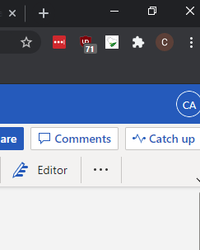 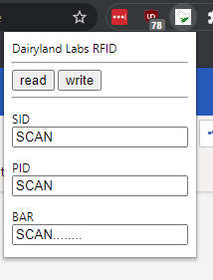

Use the RFID scanning button to bring down the scan menu and use Read and Write buttons.

(The tiny white/green beaker icon is the Dairyland scan button)

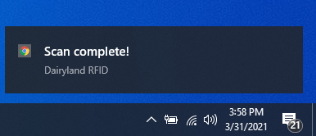

This might take a minute to appear but indicates that the read or write is done.

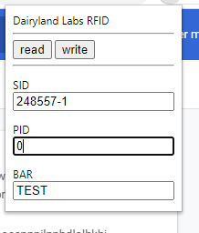 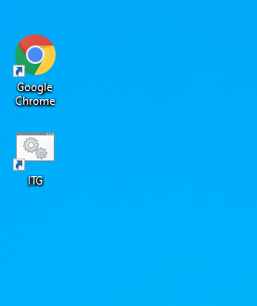

Enter the new values you want into the boxes and then hit WRITE  
You can also run the ITG scanning program instead it will pause the other program while it’s running.